Jack of All Trades
Miya Higuchi, Mason Loyet, and Rachel Ratnam
Department of Electrical and Computer Engineering, Carnegie Mellon University

Abstract— A system capable of facilitating multiplayer remote physical card games…For those who wish to play card games with friends and family in separate locations, the current alternatives available are online websites and video game software. Unlike these applications, our system aims to make card games such as Go Fish possible to play remotely while retaining the authentic feeling of holding physical cards. By utilizing computer vision and machine learning, players are now able to manually place cards on the table and draw from a deck to progress a remote game.

Index Terms— computer vision, GPIO, LCD screen, machine learning, peripherals, Raspberry Pi, TCP socket, thermal printer, tty, UART, Unix, YOLO algorithm

Introduction
Playing cards is a fun activity to spend with family members and friends, but it is difficult to do when separated by great distances. The current alternatives for remote gameplay are purely virtual, consisting of online sites and applications that lose the authentic feeling of holding and placing cards. Inspired by the nostalgia of playing with physical cards, with our system, remote gameplay using physical cards is now possible.
As the main appeal of our system is its tangibility, our approach aims to emulate the in-person playing experience while preserving simple gameplay progression. Specifically, players can manually draw and place cards by hand as their “move” as opposed to having to strictly interact with software. In addition to the primary focus on physical cards, our system aims to have multiplayer backing, game logic for specific card games, and support for concurrent games. For a deck of cards to be referenced by players in separate locations, our system will also include card dealing and card recognition to ensure that inconsistencies such as card duplicates will not occur.
For the actual implementation, the physical components of our system can be organized into input, output, and dealing devices. The keyboard will help progress the game where user input is needed. For example, during a game of Go Fish, players will need to input to the system which card rank they are requesting. The server needs to be able to know what the request is, in order to relay the information to the opponent and progress the game state. The camera module input device will act as the “eyes” of our system. It will capture the cards the user “plays” and upload the information to the server, updating the gamestate. The output device is our LCD screen, which displays the current gamestate and items of action to the user. For instance, the screen may indicate the move the opponent has just made. Lastly, for the scope of this project, the dealing device will be a thermal printer instead of a mechanical sorting machine. The thermal printer, connected to the Raspberry Pi, will print out the cards as a means of dealing. Cards will be printed out on receipt paper and supplemented with cardstock.

Use-Case Requirements
The specifications for our system mainly aim to satisfy user experience during gameplay and mitigate any inconveniences that might arise due to the remote limitations.
One specification for our project includes the minimum playing space that needs to be allocated for card recognition. The user will want sufficient enough space to play cards but will not want to have to provide an unreasonable amount either. Most popular board games are between 15” by 15” (Scrabble) and 20” by 30” (Risk). For the scope of this project, the area will be approximately 12” by 24” of table top space, such that it is within the limits of convenience for the player. This space will account for the area of all our physical devices, as well as the area necessary for the camera to recognize cards being played. The playing area size has been updated since the design report because when building the encasing for the printer, Raspberry Pi, LCD screen, and keyboard, we realized that the encasing only had to be 12” wide instead of 18” so we were able to make it more compact than we had originally planned.
Furthermore, since the system will be requiring connectivity to the server during gameplay, the user should be able to join the lobby as long as they have access to WiFi as well as an outlet to sufficiently power the devices. Once setup is completed, connecting and initializing a game between players must take no longer than 10 seconds. This metric is derived from the amount of time consumers are usually willing to spend for websites or video games to load.
Due to our system using a thermal printer to deal cards, we want cards to be dealt at a rate of at least one card every two seconds. This is so the player doesn’t have to be idle for too long during the beginning phases of the game, such as when players are being dealt their preliminary hands. Since the players will not have to wait for their opponent’s card to be dealt with the same device, this frequency is more closely modeled to the speed of casual gameplay.
Additionally, for card legibility, the fonts used should be at least 16 pixels (size of 12 point font). Most printing media use and recommend a 12 point font, so this metric was decided in order for the cards to be readable for a broader range of players. Also, the physical card sizes must be at least 3” by 2”. Standard playing cards used by casinos and professional settings are typically 3.5” by 2.5”, but for our project, the cards will be 3” by 2” (slightly larger than standard mini sized cards).
For specific games that will be implemented, our minimum viable product will be to have a fully functional remote game of Go Fish.

Architecture and/or Principle of Operation

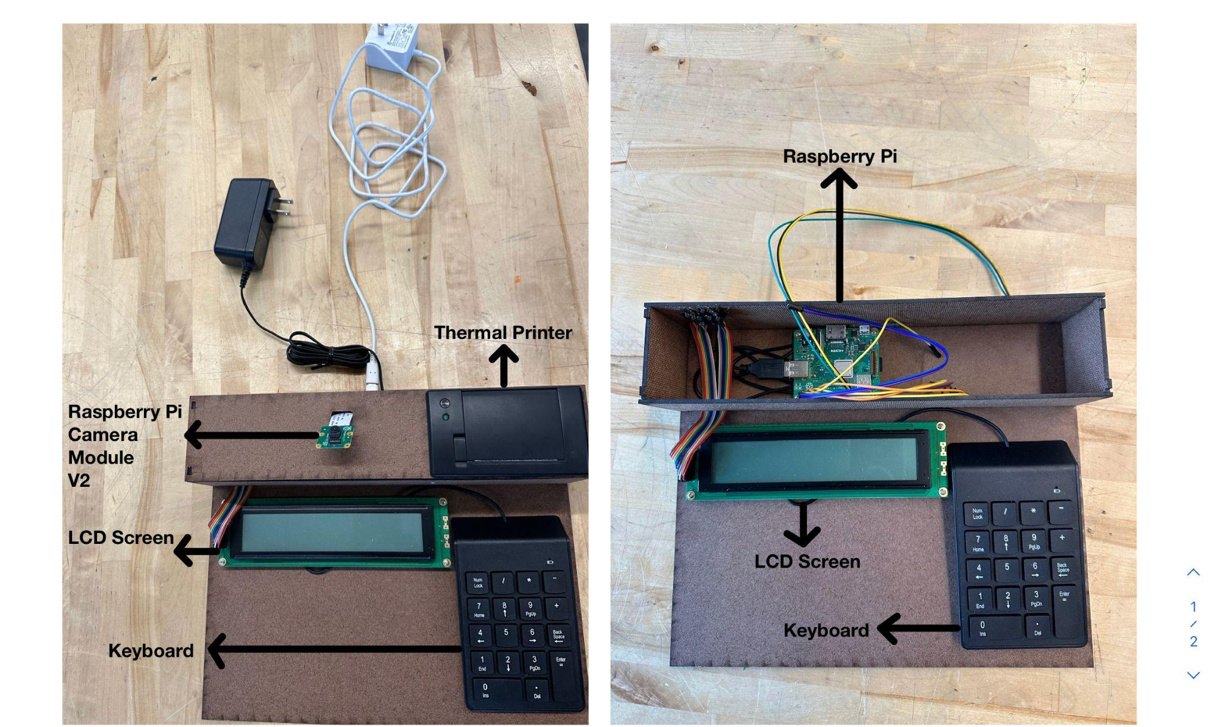
- Device Setup

The physical set up of our system is illustrated in Fig. 1. The player will be sitting adjacent to this entire contraption and they will not be able to see the Raspberry Pi or any of the wiring. They will just have to plug in the two wires above to begin playing the game.
To initiate and join a game, participating players must join a game lobby. For a given game lobby there exists a server (which may be hosting several game lobbies concurrently) and a set of 2-5 devices. Each device system allows exactly one person to interface with the game, and can be located anywhere as long as it is connected to power and wifi. Devices do not communicate point-to-point with each other. Instead, each device system has a single TCP socket connection to the server over which all communication occurs. The Raspberry Pi serves as the central hub that connects to our peripheral devices, relaying the inputs and actions from the player to the server. Using the Raspberry Pi, information in the form of JSON objects will be sent to the server to be interpreted as commands and responses.

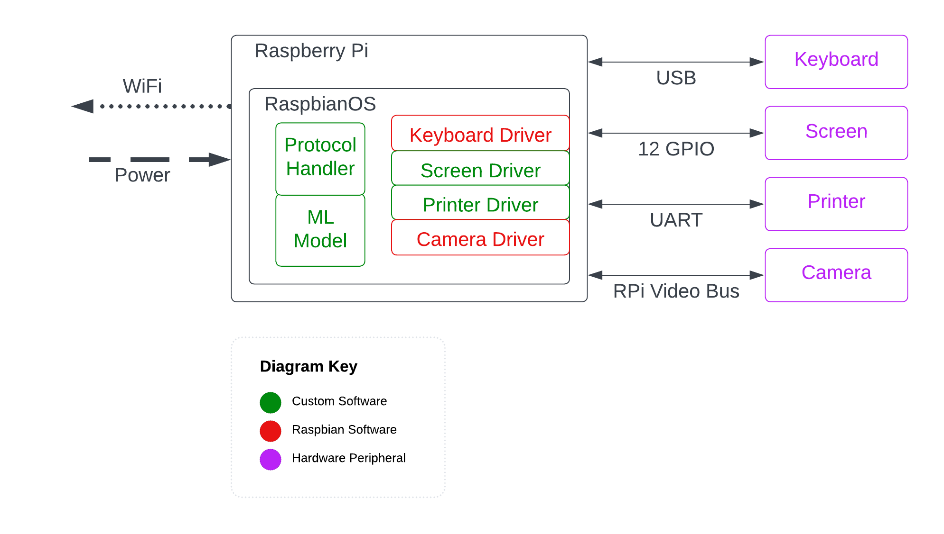
Fig 2. Device Block Diagram
The specific configurations of each device to the Raspberry Pi are shown in Fig. 2. The keyboard will be connected to the Raspberry Pi via the USB port, LCD screen will connect to the GPIO pins, the printer is connected via UART wires, and the Raspberry Pi Camera module’s ribbon connector will be secured to the Raspberry Pi Camera Serial Interface (CSI) port.
RaspianOS will take care of the device drivers necessary to communicate with the keyboard and camera. For the LCD screen and printer, they will be interfaced separately.
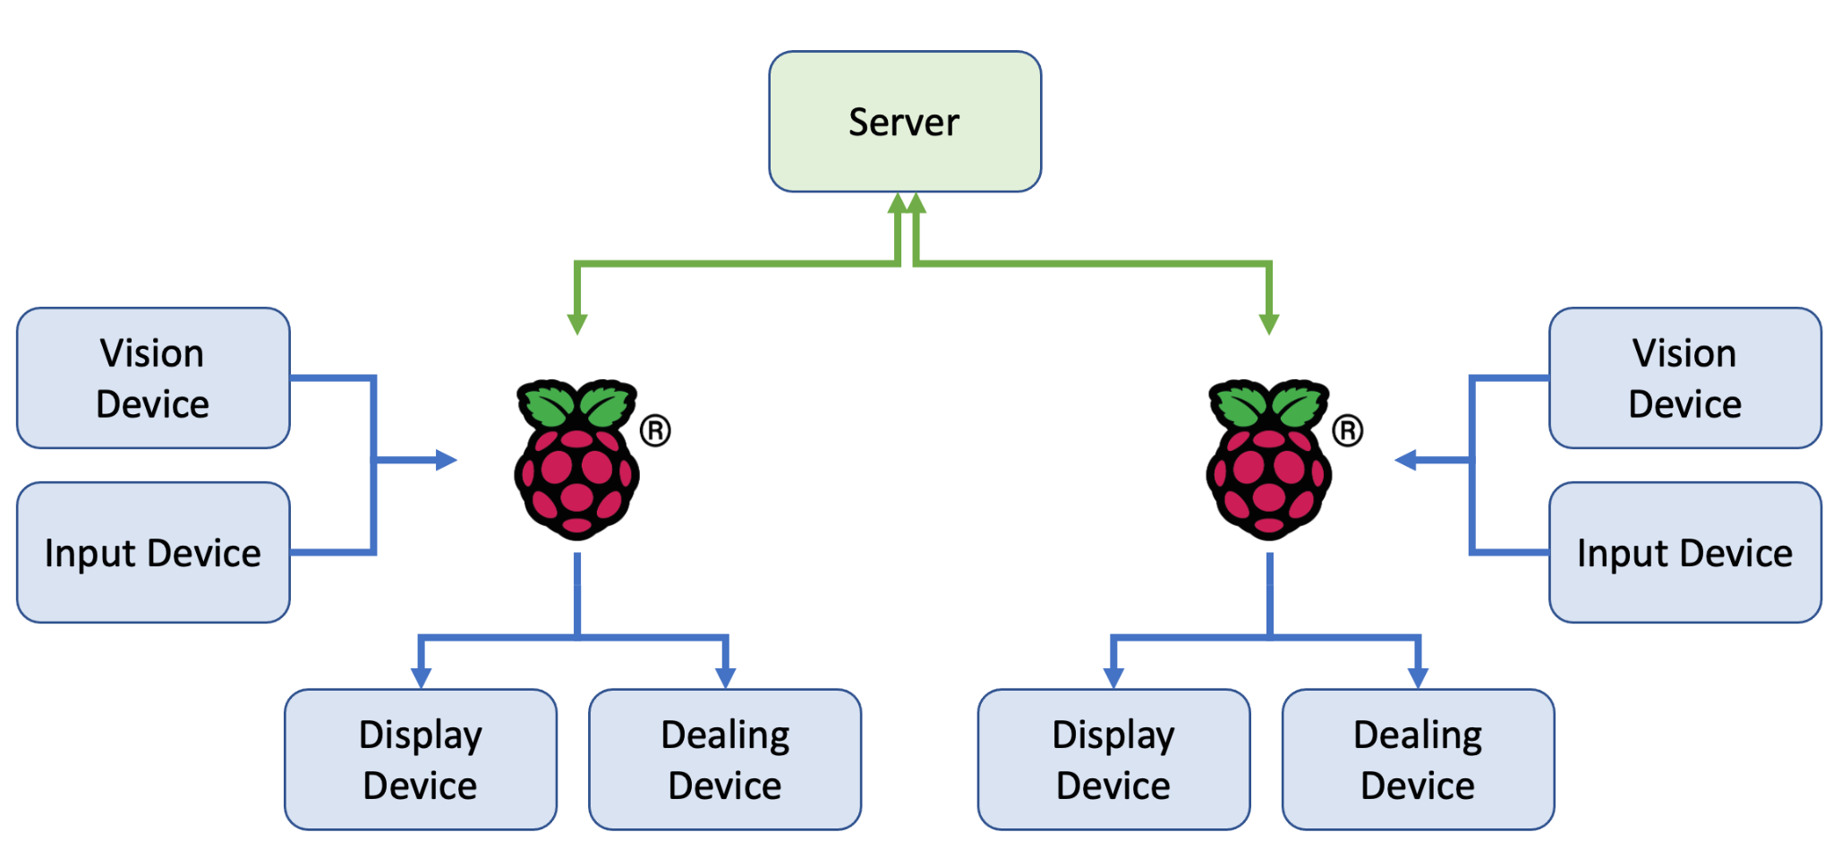
Fig 3. System Block Diagram
In Fig. 3, we can see how each of the different devices will interact with each other. Each of the individual device’s Raspberry Pi’s will be connected to the server where the game logic will be updated.

Design Requirements
The most noticeable aspect of playing a card game is the cards. Our use case requirements state that we need to be able to play with physical cards, but in order to play with physical cards in an acceptable way, we need to set some quantitative requirements.
The cards need to be printed accurately. We expect for the printer to be able to flawlessly print an entire deck of cards such that both a human and the camera is able to detect every card. In order to meet this requirement, the design must be resistant to misprints. The suit and number will be at least double redundant in the upper left and bottom right corners.
Also, the cards need to be printed quickly. In a game of cards using a real deck and human dealer, the dealer will shuffle the deck a few times before dealing out the cards. If the shuffling takes about 5 seconds and 4 cards are dealt a second, it would take 10 seconds for a human dealer to deal 5 cards to 4 people. Since we do not have to shuffle the cards and we can deal all the cards in parallel, our design requirement is to deal 1 card every 2 seconds to match this real world benchmark.
When coupling a keyboard and a screen it is critically important that there is virtually no latency between typing and having the text appear on the screen in order for the system to feel responsive. Studies show that there is a 40 ms window to show the result of an input, but there are conflicting studies, so we will require a 20 ms update latency for our LCD screen.
When playing a card game in person, you are visually able to see your opponents move almost instantly. In order to accurately emulate the gameplay experience, we must have the latency from card play to card reporting be sufficiently small. Human reaction time is about a quarter of a second, so the total latency between the time that a player plays a card and the card play being reported on all other devices must be less than 0.25 seconds.
This classification latency leads to the strictest subsystem requirements for almost all components. The allocation of time is as follows: first, we want the classification time to be around 25 ms. Then, the camera image capture time must be less than 100 ms. The network needs to also be less than 100 ms including encoding and decoding. Finally, as before, the LCD screen write latency should be less than 20 ms.
Another important aspect of playing cards is the amount of space where cards can be placed. For example, it would be very uncomfortable to play cards on an airplane tray table. We decided that a sufficient amount of space to hold the cards in a playing area with 5 people is 12 inches by 24 inches. This requirement means that our camera must be able to capture this region with enough accuracy to identify the cards. Since our receipts have precision of about 100 dpi, the image captured must be at least 2400x1800 pixels.
Finally, when not using the device it must be easy to store in a game cabinet. Our target shape is smaller than a shoebox (14 in x 10 in x 5 in) and lighter than 10lbs.

Design Trade Studies
In order to derive our final design decisions, we had to compare a lot of tradeoffs between various options and determine which one best satisfies our design requirements. Overall, we essentially had to choose the best ML algorithm, card dispensing device, camera module, and microcontroller.

Real Time Object Detection Algorithm
In terms of picking the best real time object detection algorithm, we were deciding between the Deformable Parts Model (DPM), Region-Based Convolutional Neural Network (R-CNN), and the You Only Look Once (YOLO) algorithms. In terms of picking the best algorithm, we first looked at what design requirements we needed to satisfy. Our goal for our system to be able to detect cards and be able to return its suit and rank was around 25 milliseconds. The DPM used a sliding window approach with multiple connected networks. However, because of these multiple networks it is slower and it uses static features causing it to also be less accurate. The second approach of R-CNN uses certain regions of the video to perform detections. However, this can lead to multiple detections of the same object and detecting the same card multiple times can lead to logic issues in a lot of our games. Additionally, each image can take more than 40 seconds to detect which does not align with our specifications for the design. The YOLO algorithm utilizes a single network, a grid, and feature recognition within each box of the grid which proves to be over 1000 times faster than the R-CNN and it tends to make approximately 50% of the errors that the optimized version of R-CNN (Fast R-CNN) makes. Due to this speed, we have decided to work with the YOLO algorithm for our project. The only setback for this algorithm is that it does not properly identify groups of very small times when they are close to larger items. However, this will not be an issue for us, since our camera will only be used on cards against a constant background. Once we had narrowed it down to the YOLO algorithm, it then came down to the debate of which version of YOLO to use in our final ML model. 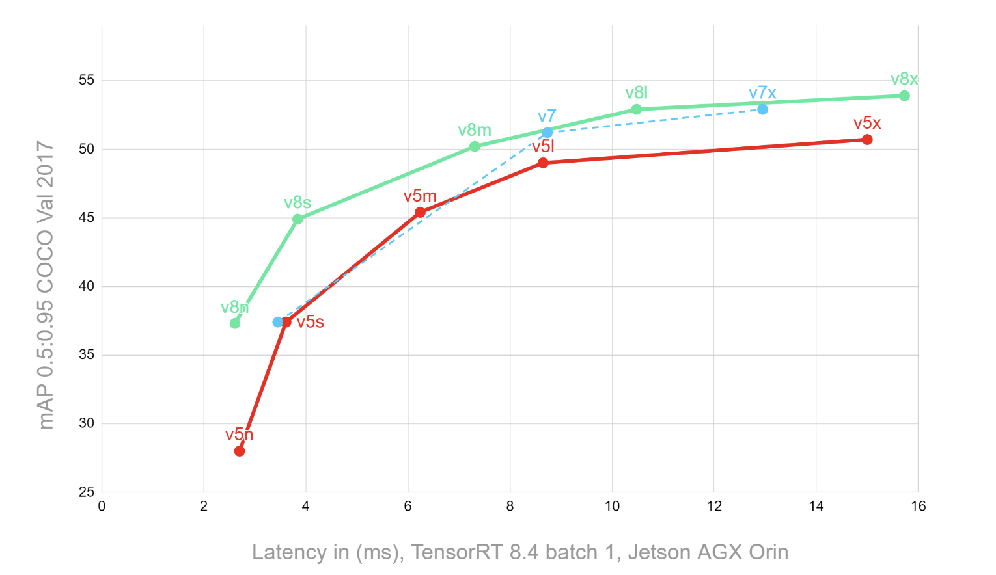
Fig 4. Comparison of YOLO algorithms [5]

The two main versions that were being debated include version 5 and version 8. Version 5 had the advantage of being a lot easier to use since its framework was simpler and only required pytorch dependencies. On the other hand, version 8 required the entire Ultralytics package to be installed on the Raspberry Pi which takes up a lot of space. However, with the use of a newer version of an OS on the Raspberry Pi, this issue was avoided since the device was still able to download the entire package without running out of memory. Due to this issue being avoided and version 8 being faster and more accurate than version 5, we decided that the best choice for our final ML model would be YOLOv8. We can see this comparison in Fig. 4, where we see the accuracy and latency of YOLOv8 outlined in green outperforming the YOLOv5 model outlined in red. [5] This speed and accuracy will help us meet the user requirements of classifying a card in under 25 milliseconds and ensuring that the correct card is classified every single time with the higher accuracy rates [7]. The limit of this algorithm is that its final model is very large and complicated which is why its accuracy is so high. Without the GPU of a computer, this may lead to a slower detection rate when on the Raspberry Pi. At this point there will have to be a tradeoff between accuracy and speed.

Card Dispensing Device
The next decision we had to make was how we wanted to actually deal the cards. When making this decision, we had two options. The first option was a mechatronic device that would have one set of standard playing cards in it. It would then contain a rotary device that would sort through the cards and then eject the card that is necessary at that moment. This first option has a lot of moving parts such as a rotating device that would be able to understand how much to rotate and how much to spin. It would then have to be able to eject one card. It would also have to be able to take in a card and place it in the rotating mechanism in the right order according to the card’s rank and suit so that it can be properly found the next time around. The second option was to purchase a mini thermal printer. This printer would essentially serve the purpose of printing out disposable versions of the card as needed. So the shuffling of the cards would occur within the software and according to the game logic, certain cards will be assigned to a user. As a result of that, the printer would proceed to print those cards out. To make it feel more like a card, the user can attach the printed receipt cards onto a piece of cardstock with a clip. At this point, we decided that both of these designs achieve our need to give cards to the user. Although, it more environmentally friendly to use the first option, due to the scope and time constraints of this project, it made more sense to use the second option because no one on our team specializes in mechatronics or robotics so building this contraption would be out of scope and instead designing and coding cards to be printed from our thermal printer made more sense. Utilizing a thermal printer, we would also be able to meet our user requirements of dealing out cards in a more efficient manner and deal them accurately as mentioned in our design requirements. With full control over what gets printed and without having to deal with the mechanical aspects of shifting gears until we get to the right card, we should be able to print out the cards with 100% accuracy based on the game state.

Camera Module
In terms of the camera we were going to use, the only specification we were looking for is easily integrable with our Raspberry Pi and computer vision model so that detection of cards was as efficient as possible. When looking for cameras that fit these specifications, it made the most sense to use one that was compatible with the Raspberry Pi since it has a camera driver. Therefore, we decided to use the Raspberry Pi camera module version 2 that works well with the Raspberry Pi. It also has a still resolution of 8 megapixels and sensor resolution of 3280 × 2464 pixels which was a high enough resolution and quality for our machine learning model to perform well. Another aspect of the camera module was its field of view because as mentioned by the design requirements, the camera will be propped up in a way such that it is overlooking the vision area, so the camera must have sufficient vertical and horizontal fields of view so that it is able to cover the entire area. With a horizontal field of view of 62.2 degrees and a vertical field of view of 48.8 degrees. Therefore, with these, it was sufficient to see the whole vision field and easily integrable with our Raspberry Pi. We changed this from the Raspberry Pi Camera Module Version 1 as specified in the design report for multiple reasons. The primary reason we had decided to use the Version 1 was because it was in stock in the inventory. However, when using the camera, the pictures ended up being extremely pixelated and blurry and we found that it did not have a lens. Even with the lens, the quality of the pictures were not high enough compared to the necessary quality for the computer vision machine learning model. Therefore, we decided to upgrade to the Raspberry Pi Camera Module Version 2 which ended up successfully taking high quality photos which matched the scope of the training data that was fed into the YOLO algorithm.

Microcontroller
For the microcontroller of this project, it came down to two options. The first option was the STM32 microcontroller and the second was the Raspberry Pi 3. Both microcontrollers had their pros and cons. The STM32 was integrated with wireless wifi and it is a much smaller and cheaper device than the Raspberry Pi. However, the Raspberry Pi 3 has software that is meant to drive a lot of the components of our project. For example, we can utilize the camera driver and the keyboard driver provided by the Raspberry Pi and we can integrate it with an operating system that we develop. Therefore, due to these properties and advantages of the Raspberry Pi 3, we decided to go with that.

System Implementation
As outlined in the architecture, the network topography forms a star with the server in at the hub and devices as peripherals. The server’s software manages the connections to the peripheral devices and holds the consensus of the game state by authority. We emphasize this centralized state philosophy as much as possible by designing the devices to
hold little to no state about the game. While connected to the server, they simply relay their I/O through messages.
The device itself runs the Raspberry Pi OS and attempts to follow Unix best practices to be as simple and infallible as possible. Specifically it interfaces with the camera, the receipt printer, the LCD screen and the keyboard through sysfs which is a pseudo filesystem which lets us interact with various data structures and files [10]. The implementation of these file interfaces are explained in more detail in their respective sections.

Server
In order to simplify development, the server consists of a second Raspberry Pi 4. Originally, we intended to use an EC2 instance to produce a more scalable solution, but in terms of getting a prototype, using hardware instead of cloud infrastructure makes the development process much simpler. Also, the costs associated with the EC2 instance can be avoided by instead using raspberry pi from the class inventory.
The software running on the server will be written in Rust to allow for easier concurrency and greater static guarantees of memory safety. The architecture will be fairly simple. There will be a single acceptor thread that handles requests to connect to the server by either creating a new game lobby or adding the client to an existing lobby.
A lobby consists of a unique name supplied by the creator, a game type, and an expected number of players. The lobbies are associated with threads which will be taken from an idle thread pool by the acceptor thread. This model lends itself to the 3 states of threads depicted in Fig. 2. All threads begin idle before a lobby is attached. Then once the thread is given a lobby by the acceptor it is in the waiting state until the game is started. Then, once the expected number of players attach to the lobby and the game starts, the thread is put in the active state for as long as the game is being played. When the game ends, the lobby is disbanded and the thread returns to the idle state. If a game lobby is abandoned before it starts, the thread may return to the idle state without a game starting. This may also happen if the lobby sits unfilled for a long period of time. These considerations are important as to not exhaust our thread pool waiting for games that will never start.
Once a game starts, a game state object will be created to accompany the lobby object. Every game has a different game state object to reflect the rules of the game. While a game is being played, it will be in the game loop. At any given time it is exactly one player’s turn. This player is called the active player. A turn consists of two stages: the play stage where the active player does their move, and the reconciling stage where the active player’s action is reconciled with all other players in the game.
During the play stage, the game state object will dictate what messages to send to the active player. The active player will then apply some input to the device which will be visible in the form of messages received on the server. All messages from the active player will be passed to the game state. The game state will indicate if the messages received have completed the active player’s turn. For example, in Go Fish, the active player would be prompted to input a player and a suit to request. When the server receives messages that the player typed something into the keyboard, the server passes these messages to the game state to be verified. It may be the case that the game state needs to send more messages to the player if they give illegal or unexpected inputs.
After the play stage is complete, the reconciling stage begins. The game state will dictate what messages to send to all players. This time, all messages from all players will be sent to the game state object. Again, the game state object will indicate when the reconciling stage is complete. In the Go Fish example, this would include sending a message to the requested player to give up the cards of a certain suit. The player would place all such cards in the vision area. At the same time, the device can send a message to the active player to dispense the newly gained cards.
After the reconciling stage, the game may either be over, or play could continue with the next player's turn, starting at the play stage.

Server-Device Communication
The server-device communication is done point-to-point over TCP sockets. All messages are sent encoded as JSON objects. Encoding and decoding from objects is done by a Rust crate called serde. There is no device-device communication.
The protocol is designed to reflect the stateless nature of the devices. For example, lines could be buffered by the device, but are instead sent immediately to be buffered on the server side. Similarly, the server is responsible for tracking what cards were detected in the last scan, the device sends all cards detected.
The strings received in Line messages are exactly as expected except that the suit keys are encoded. The mapping is +, -, /, * to spade, club, heart, diamond. These keys will be repainted on the actual keyboard.
The LCD screen messages are fairly straightforward. Text strings are sent in the print messages. There are some embedded special characters in the string that will represent the suit characters. To be consistent, these special characters are the same as the characters sent by the keyboard. (+,-,/,*). There is also a command to clear the LCD screen. If text is sent that would overflow the LCD screen, the text will scroll down.

  - Device Supervisor
On the Raspberry Pi there will be a user space program called the device supervisor. This program establishes the network connection to the server and sends and receives all messages.
On the Raspberry Pi’s boot, this process will start. It is responsible for running ensuring that all the peripherals exist and are initialized and any associated processes are started. In accordance with Unix principles, we will attempt as best as possible to have all peripherals represented as files. See the peripheral subsystem sections to see how this is done.
This program prompts the user to enter the lobby and game information before any connection to the server is established.
Once the server connection is established, it will communicate with the 4 peripherals in order to send and receive messages as described in the protocol.
  - Printer
The receipt printer has a very simple interface in terms of communication. It uses a form of ASCII UART with a baud rate of 19200. General-purpose computers typically have very good support for serial ASCII interfaces through tty devices and the Raspberry Pi is no exception. With some configuration of the Raspberry Pi OS, it is possible to connect the GPIO UART pins directly to tty files. In our case we connect the printer to the /dev/ttyAMA0 serial device.
This means that in software, sending messages to the printer simply consists of opening the tty file and appending text to it. That being said, there is a more complicated protocol built
on top of the ASCII UART channel. In this protocol, basic text is printed directly to the printer, but through the use of escape sequences it is also possible to instruct the printer to modify text properties, print barcodes and QR codes, and even display generic bitmaps. We intend to use the generic bitmaps in order to put the suits on our cards.
As shown in Fig. 1, the printer is encased within the box so that users can easily rip out the cards as they come out and they can change out the paper if necessary.
  - Keyboard
Since we are using an off the shelf USB keyboard, we are able to use Raspberry Pi OS’s USB keyboard drivers and configuration. Similar to the receipt printer, the keyboard appears as a tty device in the file /dev/ttyUSB0.
In order to read continuously from the keyboard, we simply have a thread with the file open listening continuously and sending the lines that it reads back to the Device Supervisor for transmission.
As shown in Fig. 1, this keypad will be placed right next to the LCD screen so that users can see their inputs show up on the screen live.
  - Camera
The Raspberry Pi camera is the most complicated device by far, but has the best driver support. Raspberry Pi OS has a kernel module called bcm2835-v4l2 which allows us to set up several capture modes with a daemonized process. The capture mode that we will use is periodic capture to file. Once we start the daemon, whenever we want the up to date image, we just read from the file we specified in the process launch.
As shown in Fig. 1, this camera will be slightly propped above the rest of the device and angled down towards the playing area so that it can capture the full playing area and detect the cards that are played by the user.
  - YOLO
The YOLO algorithm will be applied on the real time video received from the Raspberry Pi camera module. The algorithm has a base network speed of 45 frames per second and when it is optimized, it can reach up to 150 frames per second. With real time streaming, the video can be processed with a latency of under 25 milliseconds. This algorithm takes the images from the video, resizes it to be smaller, and then splits it into an nxn grid which make up the bounding boxes. This algorithm then utilizes a single network to perform the actual detection. Within each box, our algorithm will determine if the center of the object is in the grid cell. If that is true, then that specific grid cell will work on detecting what the object is [1]. The actual network will have 24 convolutional layers, 2 fully connected layers. a 3x3 reduction layer, followed by a 6x6 convolutional layer [8]. We will be utilizing linear activation functions within the layers and using the sum of squared errors to perform the computations within the layers. The dimensions of the network have changed from the design report due to the shift from YOLOv5 to YOLOv8. These layers have been updated by the Ultralytics package in order to increase accuracy.
  - LCD Screen
The LCD screen has a pretty complicated interface. It is a 11-pin GPIO bus. On top of 8 pins for data transmission, there is also a r/w pin and register select pin. The last pin is used for an operation-enable signal to tell the device to interpret the bus as a command.
The interface I have described is the interface to the ST7066 chip. Internally this chip interprets the 11-pin bus and actually lights up the pixels in the LCD screen. This chip has the same interface as a much more popular chip called the Hitachi HD44780, which has become the standard for LCD interface.
There are a number of open source kernel modules that work with the HD44780 interface. One which looks promising is called lcdi2c. This would allow us to operate the device through the file /sys/class/alphalcd/lcdi2c.

Test, Verification and Validation
When testing our design implementation, we employed a mix of both unit and integration testing, verification. and validation. We chose to split up the testing as such because it is important to test each of the individual components as we go to make sure that they all work as expected, and we also need to make sure that when they are connected, all the various integrations perform as expected. To test the performances of our physical devices, we chose the approach of testing through mocking.

Thermal Printer Unit Test
The first unit that we tested is the thermal printer. As described by our design requirements, we needed to test to ensure that our printer can print out 3.25” x 2.25” cards with the accurate corresponding suit and number in a maximum of 1.5 seconds. The code for each card is predetermined, so when we send a certain card to the printer system, it is able to output the exact card with the given specifications. The reason for these values is because the width of the printer is 2.25” and we need to fit the cardstock, so the length of 3.25” will be slightly shorter than that. In order to retain the more authentic feeling of card games, we designed our cards to be as similar as possible to the standard playing card design. Each card will have their rank (A-K) and descriptive text (e.g., “Five of Hearts”) in the top left and bottom right corners. In the middle section of the cards, the bitmapped image of the quantity of suit will be displayed (i.e. there will be five club symbols for a “Five of Hearts” card). Since the game we are testing utilizes all 52 playing cards, we made sure that all designs were able to be printed in a reasonable amount of time. The tests we utilized for the thermal printer ensured that we were able to send information to the printer and it was able to print it out exactly as expected without any of the data being corrupted. With our most updated thermal printer Raspberry Pi connection, we have a 100% accuracy of the data sent to the printer as it prints exactly as we expect it to. This met our design requirements of printing all the cards accurately and dealing the right cards.
  - Card Dealing Tests
To finalize the card designs, we experimented with different styles and sizes for the card suit symbols. We ended up going with outlined symbols instead of opaque, single colored symbols due to differences in printing quality. As shown in Fig. 5, opaque, fully colored symbols would cause uneven coloring and would drastically slow down the printing speed. We also settled for suit symbol sizes of around 64x64 pixels for this reason in addition to this size being more suitable to fit within the card size limitations.
​​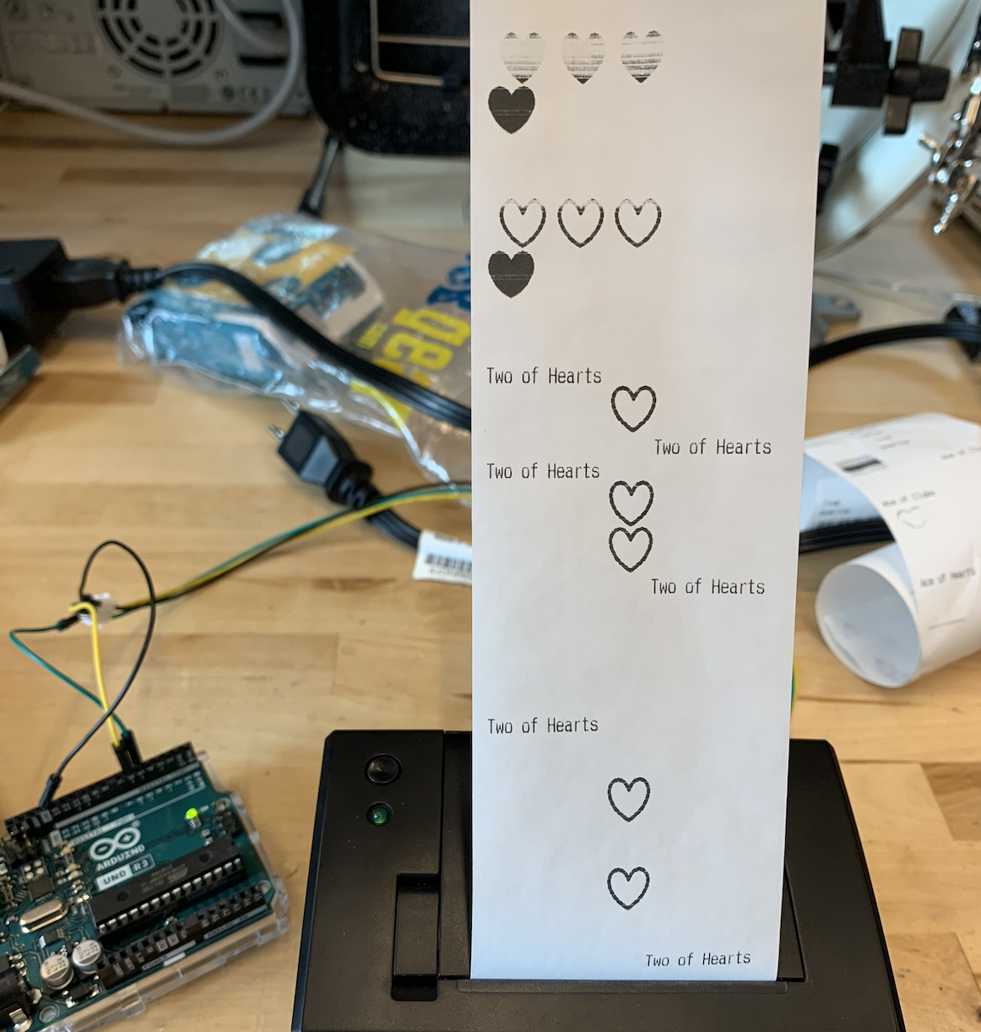
Fig. 5. Card Print Tests for 64x64 Suits
With our finalized designs, the initial print tests yielded dealing speeds of around 20 seconds per card. This was largely due to the delays of attempting to print out the filled symbols.
After removing some of these delays, we were able to achieve a worst-case printing speed of around 7 seconds. As shown in Table 1, for simpler card designs, such as the Ace of Hearts, it took the printer around 4 seconds per card. For the more complicated designs, such as the Ten of Clubs, it took closer to 7 seconds per card. These values did not meet our originally planned user requirements of 1 card every 2 seconds due to the delays of printing each of the bitmaps and the complexity of our cards. It came down to a tradeoff between speed and card design where more simplistic cards with minimal designs would print faster. However, we decided to make more actual-card like designs to give the users the most authentic experience possible with the consequence of waiting 2-5 more seconds than expected to get their cards. This however did meet our user requirements of the card legibility designs because all of the fonts were very clear and easy to read and the bitmaps indicating the suit were prominent and easily distinguishable making it easy for the users to read the cards they were dealt.
TABLE I. FINAL CARD DESIGNS PRINT TIMING TESTS
Card (Rank & Suit) | ~Time to Print (seconds)
Ace Hearts | 2.5
4 Hearts | 3.8
6 Hearts | 5.4
8 Hearts | 5.2
10 Hearts | 6.8
King Hearts | 5.8

Camera Module and Computer Vision Latency Tests
The next test focuses on the camera with the connected computer vision ML model. Because the selected YOLO algorithm has a processing latency of under 25 milliseconds and a video detection of about 10 FPS for a non GPU device, we created a high estimate of approximately 35 milliseconds in hopes that when a new card is placed in the vision area, the system should be able to know what the suit and rank of the card is under those 35 milliseconds. In terms of our test results, we found that we were able to achieve an accuracy of 0.995 for the classification. In order to test the computer vision, we created over 2000 pieces of data and split this up into training, validation, and testing data to create the most equal split amongst all the various suits. With this training dataset, we ran our model on it to determine how accurately it was predicting each of the cards. As shown in Fig. 7 below, the model first utilizes computer vision to track and find the card in the frame. It then uses the weighted model to find the high probability for the card and then predicts what the rank and suit of the card are based on that. This testing data gave us a high accuracy of 99.5%. However, this value is still not perfect, so to account for any discrepancies, we also added logic to ensure that the card that has been detected logically makes sense for the game as well as that the card was in the user's hand prior to placing it down. This also meets our user and design requirements of accurately classifying the cards that the user is playing.
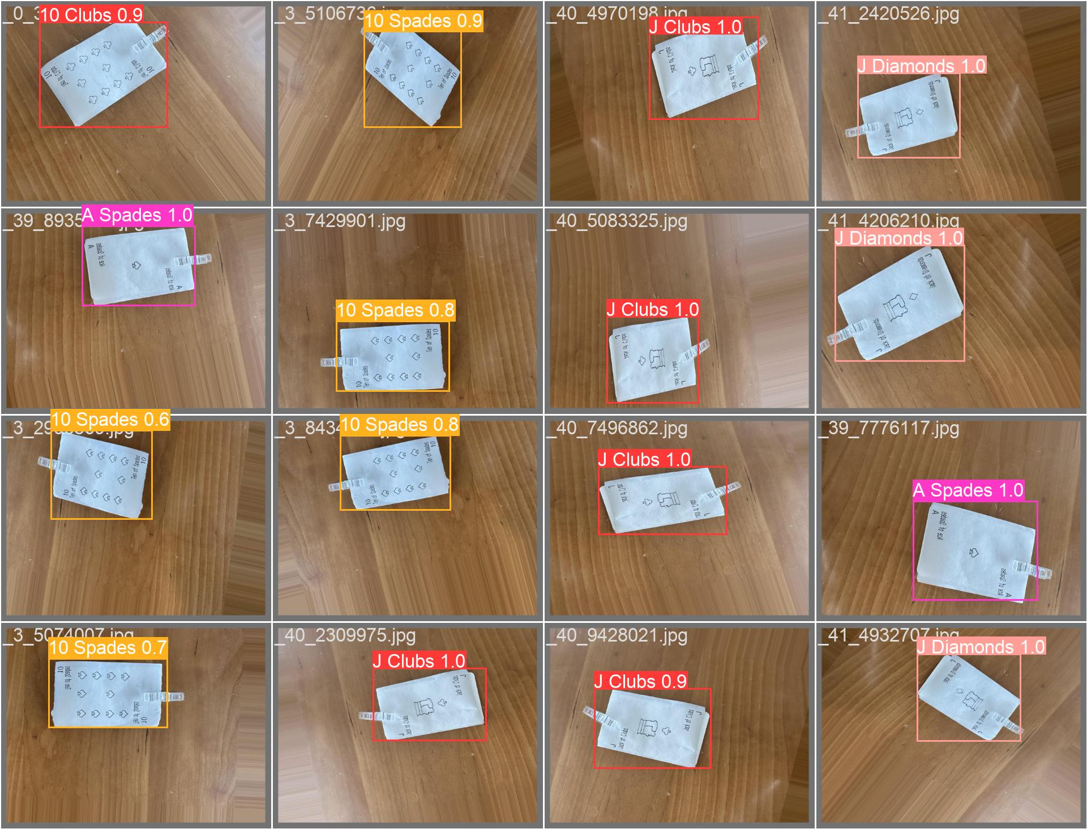
Fig. 6. Card Detection

Keyboard Input Unit Test
Next, the keyboard was tested to ensure that when the user enters in an input, it is properly received and buffer in under 10 milliseconds. This metric is the minimum value such that the human user does not experience any lag from their point of view which would be an inconvenience, so the testing ensured that the latency is at peak performance so that users do not have to wait for their inputs to show up on the screen. This testing was more difficult to actually quantify, but we measured how long it took to see our keyboard input on the LCD screen and saw no visible lag which indicated that we met our user requirements to have no lag between the input device of the keyboard and the output device of the LCD screen.

LCD Screen Unit Test
Likewise, testing for the LCD screen will include measuring how long it takes for the screen to display text and special characters like suits. As specified in our design report, our original goal was to be able to display the text in under 0.1 milliseconds. This is because for the particular screen we have selected, the frequency of reading data from the RAM is approximately 37 microseconds and the frequency of writing data to the RAM is also approximately 37 microseconds. Together, this will be approximately 74 microseconds, so an estimate of 1 millisecond will account for these 74 microseconds with a lag and also meet our design latency requirements of game state update speeds and requirements. When testing this screen, we found that updates were constantly displayed without any human visible lag which sufficiently met the user requirements we specified.

Game Logic Test
Another unit test is the testing of the implementation of the game logic and rules for the game we have selected to implement: Go Fish. Our original design report had planned to implement Go Fish, Euchre, and Rummy. However, due to time limitations and the scope of the project we have decided to limit this scope to just Go Fish because this game incorporates all the different pieces of the project since it requires input from the user to request cards, shows output through the LCD screen, prints cards, and also requires users to play cards in the detection area. The other two games that were not implemented for the demo are easily integrable since it just involves adding the game logic rules. This testing will be more logic based and can contain user testing. The user of our test suites ensures that all of the rules are properly implemented within the system and it understands all of the smaller protocols such as how many cards to pass out, how turns work, what inputs to take, and more.
To test out how the system will handle players cheating or accidentally playing illegal moves, we implemented checks after move detection that validates the intended move with the game state. For instance, for Go Fish, if a player attempts to make a set of four cards with the same rank, they would simply place the cards under the camera to be detected. In the scenario where the user reuses cards that are not currently in their possession, the system would validate whether the submitted cards are in their possession and reject the move. When this occurs, a message will be displayed on the LCD screen to inform the player of the corresponding error.

Device-Level Supervisor Integration
The first integration test is in regards to the software device-level supervisor. Because of our use-case requirements of multiplayer support for up to 5 players per game and the ability to have concurrent games going on at the same time, it is crucial that our servers are able to properly interrupt signals from peripherals in a timely manner without dropping or disrupting any of them. This is important, because we need to make sure that we have all of the necessary and relevant information for each of the games, and this can lead to logic problems if any of the signals are dropped or taken from other games going on at the same time.

Keyboard and LCD Screen Integration
The next integration test is with the keyboard and screen latency. As mentioned in the design requirements, due to the latency necessity of humans to process visual information with no lag, we aimed for a latency of approximately 20 milliseconds. So for testing, we ensured that keypresses performed by the user on the 10 key keyboard show up on the screen within the expected 20 milliseconds, which according to the latency requirements from our unit testing for the individual components is very reasonable because it accounts for the time in between to send the data from the keyboard to the LCD screen.
  - Server and Device Network Protocol Integration
Finally, the last integration test we performed is testing the network protocol between the server and device. The device supervisor should be able to send game state update messages to the server in a timely manner and the server can reconstruct a matching local game state. The reverse is also true here and the server can send commands to the device which are again serviced in a timely manner. This is to ensure that the communication between the devices is efficient and can keep up with the flow of the game.

Project Management
In order to manage this project efficiently, we have created a project schedule for the entire semester with goals, tasks, and deadlines so that we can stay accountable and ensure that the project is completed in a timely manner. Based on the skills of the three individual team members, we have also split up this project into various tasks and then assigned them to the appropriate member based on their specialties. Finally, we have also created a bill of materials with budget and risk mitigation plans to ensure that we are able to feasibly build this project and have a working end result at the end of the allocated time period.

Schedule
The projected schedule for our project’s milestones and deadlines is displayed in Fig. 7. The overall project has essentially been split up into different tasks with three distinct paths allocated on the schedule for the three members. The schedule goes up until the end of May when the project is due. Each of the 23 tasks has at least one person working on it and is organized in such a way that tasks that depend on others are scheduled so that all dependencies are met prior to starting it.
This schedule has changed since our design reports for multiple reasons. First of all, the ML aspect of the device ended up taking longer than expected because of the need to create our own custom dataset that was comprehensive enough to be able to accurately train our model. It was also delayed because of the need to create bounding boxes and label every single one of the almost 3000 pieces of data. Similarly, our hardware was also delayed because of issues with our camera and waiting for ordered parts. Due to these various delays, our schedule got shifted back a bit, but since our schedule had accounted for potential issues, we are still on track to complete our project by the demo.

Team Member Responsibilities
As shown on the schedule, there are three main paths for the team members to take on. The first path focuses on the machine learning model with reading papers, comparing models, locally creating the computer vision, and writing the test driven development for the computer vision. Rachel had the primary responsibility of handling the machine learning model and hooking up the computer vision to the device for this project because of her minor in machine learning and particular interest in the field. Her secondary responsibility was helping the software track as necessary when the other members are running into problems or if she completes her parts early. The second path described in the schedule consists of more hardware components which will include defining a protocol, building a mock server, a CV debug dashboard, a peripheral dashboard, and performing test driven development on the keyboard, camera, LCD screen, and the thermal printer. This role was the primary responsibility of Miya, who is concentrating in hardware in her degree. Her secondary responsibility was helping Mason with the software path which is described next. The final path will include defining the protocol, building a mock device, writing test suites for Go Fish, and performing test driven development on the game. Mason’s primary responsibility was this due to his concentration in software and specialties in systems. His secondary responsibilities was helping Miya with the hardware track as needed. All three members will then come together to work together and integrate the game once the rest of the work is done and then will also work on optimizing the system as time permits.
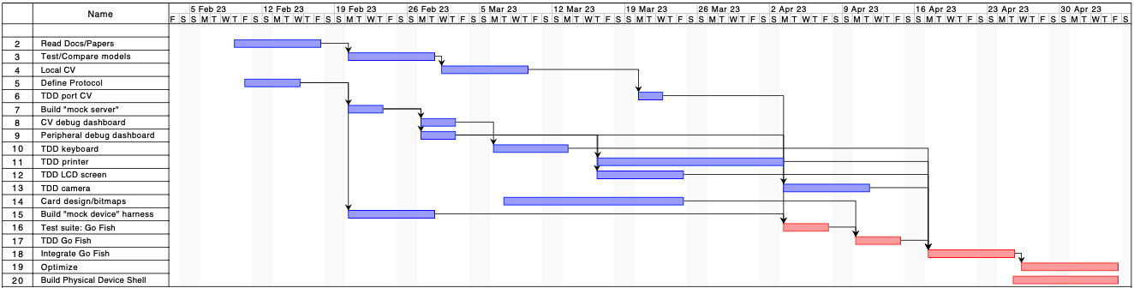
- Project Schedule

Bill of Materials and Budget
The bill of materials and budget can be seen at the end of the report on Table II. Some items have different total costs due to shipping.
Throughout our development process, we found that some items weren’t compatible or able to meet the needs of our devices. The items that are not used in the final design are indicated by red highlights and those that were used are indicated by green highlights.

Risk Management
In terms of schedule risk management, due to the delays in both the machine learning data collection and the ordering of the hardware pieces, we had to create back up plans and reorder the way we attacked our project to incorporate these delays. While the data was being compiled to train the model and while the final model was training, we worked on getting the camera and software ready so that the model was easy to integrate. Likewise, while waiting for the camera hardware pieces to arrive, we dealt with integrating the keyboard and LCD screen, which reordered the original plan of action we had created.
To manage budget risks, we sought to buy early and test as we further developed our systems. This allowed us to encounter issues such as our camera module not working in time so we could order a more compatible version. We also checked the inventory for suitable devices before buying new technologies. As a result, we were able to test out and compare a couple Raspberry Pi’s and camera modules for compatibility. When we had to order parts, we went for the more cost-effective options, such as the thermal printer, making sure that the devices were able to meet the specifications we had. As a result, we managed to be well within the allocated budget of $600, with our total costs being $270.30.
Most of the obstacles we encountered throughout this semester were in part due the differences in performance expectations we had of the device or software.

Ethical Issues
When looking at the possible ethical considerations with our project, we identified a few worst-case scenarios. These cases included potential safety hazards in operating the product, hacking, environmental repercussions, or psychological damage. The outcomes from these scenarios are something we recognized because the original intended use for our project was to bring people together using the nostalgia of physical card games, not to cause bodily harm.
For potential safety hazards, this could include electric shock or fire from exposed or malfunctioning electrical components. Our product contains a lot of wired connections between the devices, so it is possible for wires to get disconnected during use or transit. We’ve tried to mitigate this from happening via creating the outer shell to house all of our units. In terms of hacking, there is a risk that the Raspberry Pi can be hacked because it is connected to WiFi for gameplay. This is a potential harm due to the connected camera module that may be misused to stream the inside of the user’s house. Due to the scope of our project, this risk can be mitigated by advising users to properly power down the system by unplugging the power adapter. Additionally, downloading antivirus software or programs that monitor failed SSH login attempts could help reduce this risk. Relating to the environmental repercussions, this refers to the consequential use of paper that is necessary to operate the product. An approach to mitigate this in the future would be to fully implement a mechatronic card dealing and shuffling system in place of the thermal printer.
In these situations, those who are not technologically-apt, such as young children or the elderly, are more vulnerable because they may not understand how to properly store and operate electrical products. Providing instructions, consumer warnings, and advised age recommendations would hopefully minimize the possibility of consumer-related harm.

Related Work
Our product is unique in many ways. One similar idea is that there are multiple online card game platforms. These offer a multitude of various games that people can play with their friends online but none offer a way to play with physical cards remotely. Additionally, there is a patent out there for a system that plays card games remotely that performs a very similar functionality as ours but uses mechatronics instead of a thermal printer [9]. This patent has been used multiple times for various card dispensers, blackjack and poker apparatuses, and more. However, our work differs from these because we focus on Go Fish which have not been implemented yet.

Summary
Overall, our system allows for people to play cards with their friends and family remotely while still maintaining the feeling of playing physical cards. This will continue to bring people together even when separated by great distances. The thermal printer provides any card to the user and the design of the keyboard and LCD allows for the users to easily and efficiently input whatever they need to and witness it appear on the LCD screen. Additionally, the implementation of the Go Fish game logic allows for the users to play this super fun game similar to how they would play them in real life. With various risk mitigation techniques and design tradeoff decisions that were made, we were able to primarily meet our use-case and design requirements. Our system meets the specifications for usability and logic since you can play a full game of Go Fish with physical cards in a timely and efficient manner. However, the system does not meet our original requirements in speed for dealing cards, so with more time, we could improve the card dealing experience by building a mechatronic device that would use one deck of 52 cards that dealt the cards in a faster manner than manually printing each and every card for every single card which would also save a lot of paper. Also, since we only made one device, only one lobby is supported at a time. With more time, we would also add more games by integrating more logic which shows the versatility of our entire device since it can be used for a plethora of various games.
For future student groups interested in developing similar projects where integration of physical devices are necessary, we would advise them to thoroughly research the parts that they order in advance. When working with unfamiliar devices, they may run into issues where they aren’t able to use the desired software or libraries that were critical to their implementation process because the ordered devices are not compatible. In these cases, ordering early and making sure the version or model is suitable to their system specifications is crucial. To mitigate these risks, we recommend that performing small integration tests as early as possible to ensure that troubleshooting later on will not upheave the foundation of the project.
Glossary of Acronyms
ASCII – American Standard Code for Information Interchange
CSI – Camera Serial Interface
DPM –Deformable Parts Model
EC2 – (Amazon) Elastic Compute Cloud
GPIO – General Purpose Input Output
ML – Machine Learning
LCD – Liquid-Crystal Display
OS – Operating System
RHEL – Red Hat Enterprise Linux
RPi – Raspberry Pi
R-CNN – Region-Based Convolutional Neural Network
TCP – Transmission Control Protocol
UART – Universal Asynchronous Receiver Transmitter
USB – Universal Serial Bus
YOLO – You Only Look Once
References
- Wang, Chien-Yao & Bochkovskiy, Alexey & Liao, Hong-yuan. (2022). YOLOv7: Trainable bag-of-freebies sets new state-of-the-art for real-time object detectors. 10.48550/arXiv.2207.02696.
- Jain A, Bansal R, Kumar A, Singh KD. (2015). A comparative study of visual and auditory reaction times on the basis of gender and physical activity levels of medical first year students. Int J Appl Basic Med Res. 2015 May-Aug;5(2):124-7. doi: 10.4103/2229-516X.157168. PMID: 26097821; PMCID: PMC4456887.
- Deber J, Jota R, Forlines C, Wigdor D. (2015). How Much Faster is Fast Enough?: User Perception of Latency & Latency Improvements in Direct and Indirect Touch. 978-1-4503-3145-6
- “YOLOV8 - Predict.” Predict - Ultralytics YOLOv8 Docs, https://docs.ultralytics.com/modes/predict/
- Gabriel. “Performance Benchmark of Yolo V5, V7 and V8.” Stereolabs, 17 Jan. 2023, https://www.stereolabs.com/blog/performance-of-yolo-v5-v7-and-v8/.
- Brownlee, Jason. “Image Augmentation for Deep Learning with Keras.” MachineLearningMastery.com, 6 Aug. 2022, https://machinelearningmastery.com/image-augmentation-deep-learning-keras/.
- Ultralytics. “Ultralytics/Ultralytics: New - yolov8 🚀 in PyTorch &gt; ONNX &gt; CoreML &gt; TFLite.” GitHub, https://github.com/ultralytics/ultralytics.
- Solawetz, Jacob. “What Is Yolov8? the Ultimate Guide.” Roboflow Blog, Roboflow Blog, 25 Jan. 2023, https://blog.roboflow.com/whats-new-in-yolov8/.
- Penzias, Arno A. “System For Playing Card Games Remotely” Patent 5,397,133. 14 Mar. 1995. Google Patents, https://patents.google.com/patent/US5397133A/en
- “Sysfs(5) — Linux Manual Page.” Sysfs(5) - Linux Manual Page, https://man7.org/linux/man-pages/man5/sysfs.5.html.

Fig. 8. Device Block Diagram (Larger Version)

TABLE II. BILL OF MATERIALS
Description | Model # | Manufacturer | Quantity | Cost @ | Total
AC/DC Adapter | VEL18US090-US-JA | XP Power | 1 | $13.66 | $23.56
Adapter Connector | PRT-10288 | SparkFun Electronics | 1 | $3.50 | $3.50
Camera Cable | U3848 | UCTRONICS | 1 | $9.99 | $9.99
Camera Lens Shield | IMX219-160 CAMERA MODULE 160 FOV | Seeed Technology Co., Ltd | 1 | $12.90 | $22.25
Cardstock (100 pieces) | MaxGear-Printable-Business-Cards-100pc | MaxGear.LLC | 1 | $5.99 | $5.99
LCD Screen | NHD-0440WH-ATFH-JT#-ND | Newhaven Display Intl | 1 | $31.96 | $41.29
Mini Thermal Receipt Printer | A2 Micro Pannel Thermal Printer (PID#597) | Cashino | 1 | $49.95 | $68.75
Mini Transparent Plastic Clear Clips (128 Pieces) | B08RZ7NPT5 | GALIREN | 1 | $7.92 | $7.92
Mounting Standoffs | STBR-huangtongzhu-180P | Sutemribor | 1 | $14.99 | $14.99
Protoboard | PI-TOPPROTO | Pi-Top | 1 | $6.99 | $6.99
Raspberry Pi | 3A+ | RaspberryPi | 1 | $0.00 | $0.00
Raspberry Pi | 4 (2GB) | Raspberry Pi | 1 | $0.00 | $0.00
Raspberry Pi Camera | Module V2 | Raspberry Pi | 1 | $25.00 | $33.91
Raspberry Pi Camera | Module V1 | Raspberry Pi | 1 | $0.00 | $0.00
Micro SDXC Memory Card (128 GB) | ‎LSMICRO128GU3 | Amazon Basics | 1 | $12.42 | $12.42
Thermal Paper Roll (50' long, 2.25" wide) | AdafruitPID#599 | Adafruit Industries LLC | 5 | $1.95 | $9.75
USB Numeric Keypad Numpad | NK895 | NOOX | 1 | $8.99 | $8.99
 |  |  |  | Grand Total: | $270.30

tty files act as access points to the hardware devices

