We break the system into 6 functional blocks and specify their implementation as well as the interface between them.

Pre-Amplifier
Accepts voice or instrument input and produces an amplified analog output signal, with tunable gain.
We will use an instrumentation amplifier (INA2332) tuned by a digital potentiometer (MCP4451) AND a multiplexed gain block (MCP6007 op-amp and SN74LV405 mux select) for 3 gain modes, each with tunable gain (see pic). The gain modes and fine-grained potentiometer settings are controled by the microprocessor and selected by the user through UI module.
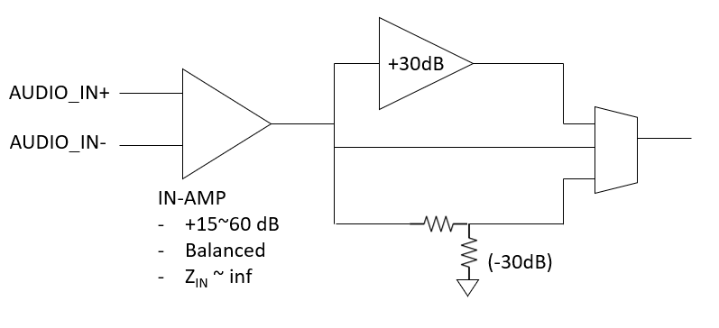
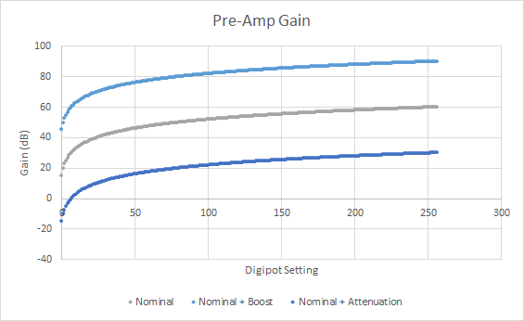
Analog Effect
This module implements effects preferable and unique in the analog domain: delay and overdrive; it complements the digital effects produced by the microprocessor.
We will implement them using op amps, diodes, and RC filters with reference to commonly adopted delay/overdrive circuit designs, e.g. found on beavisaudio.com.
Each of the inputs will have its own analog effect module switched by the microprocessor as specified by the user.
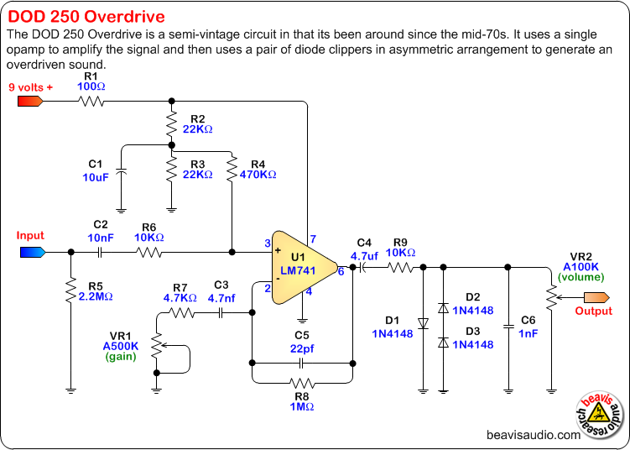
RF Module
The RF module sends the processed audio through Bluetooth to any common Bluetooth speaker.
We use the BM83 Bluetooth module which supports AAC and SBC codecs, allowing us to pair to most Bluetooth speakers. The microprocessor sends the processed digital signal to the RF module through I2S (Inter-IC Sound Bus), and controls the module to connect to new devices or send audio.

Power Module
The system supports both rechargeable battery and direct connect to wall adapters.
We use 3.3V supply voltage for the whole system.
The BM83 Bluetooth module includes a recharge circuit which has 5V wall adapter input and 3.2 to 4.2V battery input, so we choose 1500mAh 3.7V Lithium polymer battery and a type-C 5V wall adapter (used by many smartphones), and utilize the BM83 power management module to charge the battery or power the board.
- Battery
- Wall Adapter

Microprocessor
The microprocessor controls all settings of the pre-amp and effect module, controls the BM83 module, does digital signal processing for ??? effects, and receives user commands and provides display via the UI module.
We choose the STM32F407VG microprocessor along with the MCP3464R-E/ST 16-bit ADC which connects to the analog modules. The microprocessor receives digital audio signal from the ADCs through SPI, controls analog settings through GPIO and I2C, sends digital audio signal to BM83 through I2S, receives user commands through GPIO, and controls the LCD display via the on-chip LCD driver.
- Signal Processing
- Control

User Interface Module
- Output: LCD Display
- Input: Rotary Encoder (with press button)
The LCD display shows the menu of the system, including “digital/analog mode” “pre-amp gain mode and tuner” “analog effect switch” “Bluetooth connection”.
It also displays the current mode, setting, and battery percentage of the system.
The user browse through the menu using the rotary encoder, and press down the rotary encoder to confirm selection. The LCD display also provides feedback on the user’s actions (e.g. highlights the selected menu item).
This module is controlled by the microprocessor.

